Regression-Rebuild with deep learning model
1.Introduction
Machine Learning (ML) and Deep Learning (DL) are two major branches of Artificial Intelligence (AI).

- Machine Learning (ML): Uses algorithms that learn from data without being explicitly programmed.
- Deep Learning (DL): A subset of ML that uses Artificial Neural Networks (ANNs) with multiple hidden layers.
In this project:
- Regression Task → Diabetes Prediction
- Classification Task → Heart Disease Prediction

2. Regression – Diabetes Prediction
🔹 Machine Learning (ML) Approach
Common Algorithm: Linear Regression, which assumes a straight-line relationship between features and the target.

Advantages:
Simple and easy to interpret.
Works well on small datasets.

Limitations:
Accuracy reduces as dataset size and complexity increase.
Cannot capture complex non-linear relationships.

Program:

# diabetes_ml_tf.py
import pandas as pd
import tensorflow as tf
from sklearn.model_selection import train_test_split
from sklearn.preprocessing import StandardScaler
from sklearn.metrics import mean_squared_error, r2_score

# Load dataset
data = pd.read_csv(“diabetes.csv")
print(data.head())

X = data.drop("Outcome", axis=1)
y = data["Outcome"]

# Scale data
scaler = StandardScaler()
X = scaler.fit_transform(X)

# Split data
X_train, X_test, y_train, y_test = train_test_split(X, y, test_size=0.2, random_state=42)

# ML Model (like Linear Regression)
model = tf.keras.Sequential([
tf.keras.layers.Dense(1, input_shape=(X.shape[1],)) # Single neuron, no activation])

model.compile(optimizer="adam", loss="mse")

# Train
history = model.fit(X_train, y_train, epochs=100, verbose=0)

# Predict
y_pred = model.predict(X_test).flatten()

# Evaluation
print("ML (TF) Regression Results:")
print("MSE:", mean_squared_error(y_test, y_pred))
print("R2 Score:", r2_score(y_test, y_pred))
import matplotlib.pyplot as plt
import numpy as np

# Plot training loss curve
plt.plot(history.history['loss'])
plt.title('Training Loss (MSE)')
plt.xlabel('Epochs')
plt.ylabel('Loss')
plt.show()

# Plot Actual vs Predicted
plt.scatter(y_test, y_pred, alpha=0.7)
plt.xlabel("Actual Values")
plt.ylabel("Predicted Values")
plt.title("Actual vs Predicted (Regression)")
plt.plot([min(y_test), max(y_test)], [min(y_test), max(y_test)], color='red') # ideal line
plt.show()

Output:

Pregnancies Glucose BloodPressure ... DiabetesPedigreeFunction Age Outcome
0 6 148 72 ... 0.627 50 1
1 1 85 66 ... 0.351 31 0
2 8 183 64 ... 0.672 32 1
3 1 89 66 ... 0.167 21 0
4 0 137 40 ... 2.288 33 1

ML (TF) Regression Results:
MSE: 0.1709032654762268
R2 Score: 0.2556213140487671

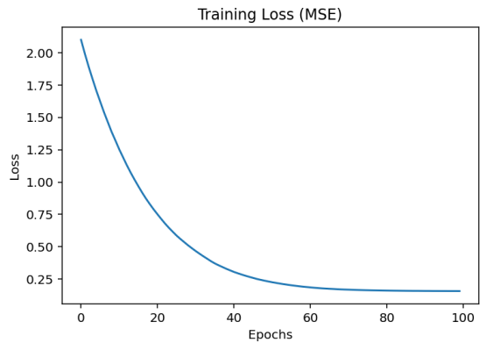

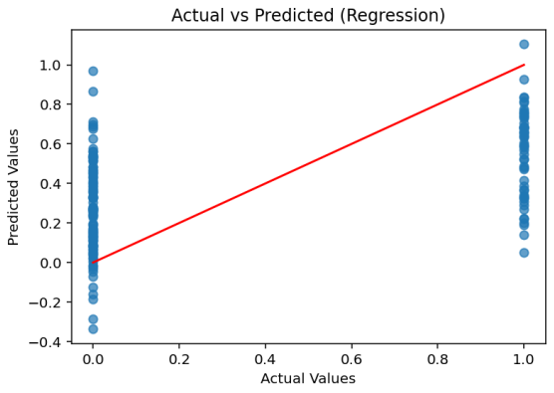

🔹 Deep Learning (DL) Approach

Structure: Input layer (features) → hidden layers (non-linear transformations) → output layer (predicted diabetes measure).

Advantages:
Learns complex patterns and non-linear relationships.
More accurate when dataset is large.

Limitations:
Requires more data and computational resources.
Less interpretable compared to ML.

Program:

# diabetes_dl_tf.py
import pandas as pd
import tensorflow as tf
from sklearn.model_selection import train_test_split
from sklearn.preprocessing import StandardScaler
from sklearn.metrics import mean_squared_error, r2_score

# Load dataset
data = pd.read_csv("diabetes.csv")
print(data.head()) # Corrected line

X = data.drop("Outcome", axis=1)
y = data["Outcome"]

# Scale data
scaler = StandardScaler()
X = scaler.fit_transform(X)

# Split data
X_train, X_test, y_train, y_test = train_test_split(X, y, test_size=0.2, random_state=42)

# DL Model
model = tf.keras.Sequential([
tf.keras.layers.Dense(64, activation="relu", input_shape=(X.shape[1],)),
tf.keras.layers.Dense(32, activation="relu")
tf.keras.layers.Dense(1) # Regression output])

model.compile(optimizer="adam", loss="mse")

# Train
history = model.fit(X_train, y_train, epochs=100, verbose=0)

# Predict
y_pred = model.predict(X_test).flatten()

# Evaluation
print("DL Regression Results:")
print("MSE:", mean_squared_error(y_test, y_pred))
print("R2 Score:", r2_score(y_test, y_pred))
import matplotlib.pyplot as plt
import numpy as np

# Plot training loss curve
plt.plot(history.history['loss'])
plt.title('Training Loss (MSE)')
plt.xlabel('Epochs')
plt.ylabel('Loss')
plt.show()

# Plot Actual vs Predicted
plt.scatter(y_test, y_pred, alpha=0.7)
plt.xlabel("Actual Values")
plt.ylabel("Predicted Values")
plt.title("Actual vs Predicted (Regression)")
plt.plot([min(y_test), max(y_test)], [min(y_test), max(y_test)], color='red') # ideal line
plt.show()

Output:
Pregnancies Glucose BloodPressure ... DiabetesPedigreeFunction Age Outcome
0 6 148 72 ... 0.627 50 1
1 1 85 66 ... 0.351 31 0
2 8 183 64 ... 0.672 32 1
3 1 89 66 ... 0.167 21 0
4 0 137 40 ... 2.288 33 1
DL Regression Results:
MSE: 0.23747684061527252
R2 Score: -0.034343600273132324

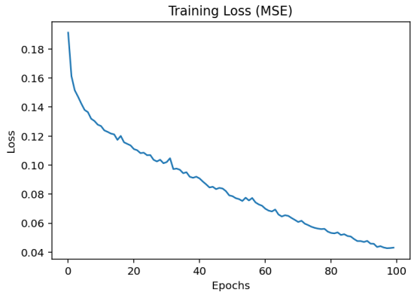
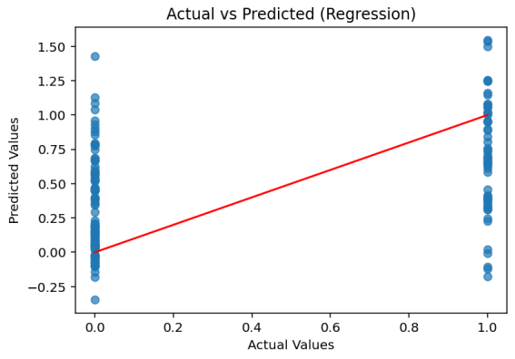

Classification -Rebuild with deep learning model
3. Classification – Heart Disease Prediction
🔹 Machine Learning (ML) Approach

Concept: Classification in ML predicts categorical values (e.g., “heart disease present” or “not present”).

Example: Predicting whether a patient has heart disease based on features like age, cholesterol, and blood pressure.

Common Algorithm: Logistic Regression, which uses probabilities to classify data into two categories.

Advantages:
Easy to train and interpret.
Suitable for small to medium datasets.

Limitations:
May not capture complex interactions among features.
Accuracy limited on high-dimensional data.

Program:

# heart_ml_tf.py
import pandas as pd
import tensorflow as tf
from sklearn.model_selection import train_test_split
from sklearn.preprocessing import StandardScaler
from sklearn.metrics import accuracy_score, classification_report

# Load dataset
data = pd.read_csv("C:/Users/Punith H J/OneDrive/Documents/heart.csv")

X = data.drop("target", axis=1)
y = data["target"]

# Scale
scaler = StandardScaler()
X = scaler.fit_transform(X)

# Split
X_train, X_test, y_train, y_test = train_test_split(X, y, test_size=0.2, random_state=42)

# ML Model (Logistic Regression = single dense + sigmoid)
model = tf.keras.Sequential([
tf.keras.layers.Dense(1, activation="sigmoid", input_shape=(X.shape[1],))])

model.compile(optimizer="adam", loss="binary_crossentropy", metrics=["accuracy"])

# Train
history = model.fit(X_train, y_train, epochs=100, verbose=0)

# Predict
y_pred = (model.predict(X_test) > 0.5).astype("int32")

# Evaluation
print("ML (TF) Classification Results:")
print("Accuracy:", accuracy_score(y_test, y_pred))
print(classification_report(y_test, y_pred))
# --- Alternative plot for classification ---
import matplotlib.pyplot as plt

# Extract history
loss = history.history['loss']
accuracy = history.history.get('accuracy', None)

epochs = range(1, len(loss)+1)

# Plot Loss
plt.figure(figsize=(8,4))
plt.plot(epochs, loss, 'r-', marker='o', label='Loss')
plt.title('Training Loss over Epochs')
plt.xlabel('Epochs')
plt.ylabel('Loss')
plt.grid(True)
plt.legend()
plt.show()

# Plot Accuracy (if available)
if accuracy:
plt.figure(figsize=(8,4))
plt.plot(epochs, accuracy, 'b-', marker='s', label='Accuracy')
plt.title('Training Accuracy over Epochs')
plt.xlabel('Epochs')
plt.ylabel('Accuracy')
plt.grid(True)
plt.legend()
plt.show()

Output:

Accuracy: 0.8524590163934426
ML (TF) Classification Results:
Accuracy: 0.8524590163934426
precision recall f1-score support

0 0.86 0.83 0.84 29
1 0.85 0.88 0.86 32

accuracy 0.85 61
macro avg 0.85 0.85 0.85 61
weighted avg 0.85 0.85 0.85 61

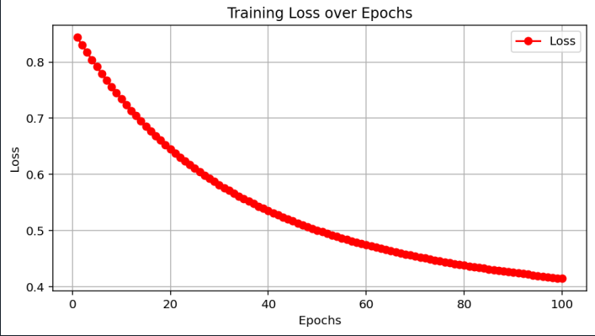

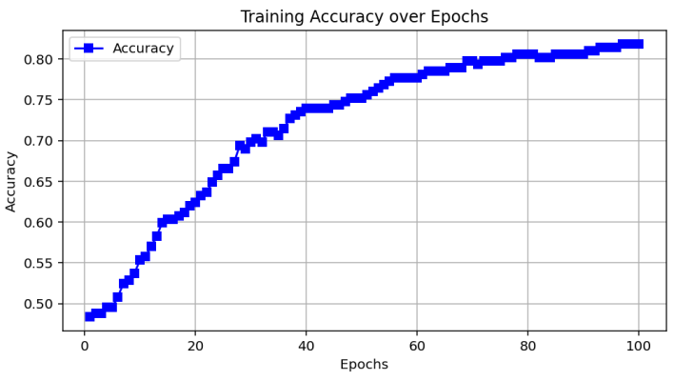

🔹 Deep Learning (DL) Approach

Concept: Uses ANNs for binary or multi-class classification.

Structure: Input layer → hidden layers → output layer with sigmoid (binary) or softmax (multi-class) activation.

Advantages:
Captures hidden patterns and non-linear relationships.
Improves accuracy when dataset is large.

Limitations:
Requires more training time and computing power.

Program:
# heart_dl_tf.py
import pandas as pd
import tensorflow as tf
from sklearn.model_selection import train_test_split
from sklearn.preprocessing import StandardScaler
from sklearn.metrics import accuracy_score, classification_report

# Load dataset
data = pd.read_csv("C:/Users/Punith H J/OneDrive/Documents/heart.csv")
print(data.head())
X = data.drop("target", axis=1)
y = data["target"]

# Scale
scaler = StandardScaler()
X = scaler.fit_transform(X)

# Split
X_train, X_test, y_train, y_test = train_test_split(X, y, test_size=0.2, random_state=42)

# DL Model
model = tf.keras.Sequential([
tf.keras.layers.Dense(64, activation="relu", input_shape=(X.shape[1],)),
tf.keras.layers.Dense(32, activation="relu"),
tf.keras.layers.Dense(1, activation="sigmoid") # Binary classification])

model.compile(optimizer="adam", loss="binary_crossentropy", metrics=["accuracy"])

# Train
history = model.fit(X_train, y_train, epochs=100, verbose=0)

# Predict
y_pred = (model.predict(X_test) > 0.5).astype("int32")

# Evaluation
print("DL Classification Results:")
print("Accuracy:", accuracy_score(y_test, y_pred))
print(classification_report(y_test, y_pred))
# --- Alternative plot for classification ---
import matplotlib.pyplot as plt

# Extract history
loss = history.history['loss']
accuracy = history.history.get('accuracy', None)
epochs = range(1, len(loss)+1)

# Plot Loss
plt.figure(figsize=(8,4))
plt.plot(epochs, loss, 'r-', marker='o', label='Loss')
plt.title('Training Loss over Epochs')
plt.xlabel('Epochs')
plt.ylabel('Loss')
plt.grid(True)
plt.legend()
plt.show()

if accuracy:
plt.figure(figsize=(8,4))
plt.plot(epochs, accuracy, 'b-', marker='s', label='Accuracy')
plt.title('Training Accuracy over Epochs')
plt.xlabel('Epochs')
plt.ylabel('Accuracy')
plt.grid(True)
plt.legend()
plt.show()
Output:

Accuracy: 0.8524590163934426
DL Classification Results:
precision recall f1-score support

0 0.86 0.83 0.84 29
1 0.85 0.88 0.86 32

accuracy 0.85 61
macro avg 0.85 0.85 0.85 61
weighted avg 0.85 0.85 0.85 61

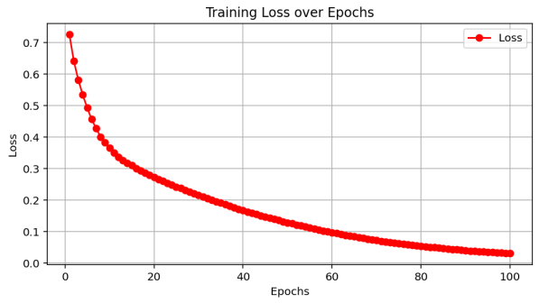

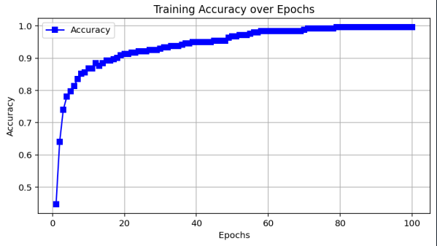

Analyze the performance of ML and DL
🔹 1. Data Dependency

Machine Learning (ML):

Performs well even on small to medium datasets (hundreds or thousands of samples).
Example: Logistic Regression or Decision Trees can classify heart disease with limited data.
Limitation: Accuracy may drop if the dataset grows very complex or has high-dimensional features.

Deep Learning (DL):

Needs large datasets to achieve high performance.
Example: ANN for diabetes regression needs more data to properly adjust weights.
Advantage: Learns directly from raw data without much manual preprocessing.

🔹 2. Training Time & Resources

ML:
Training is fast and requires low computational power.
Can be executed on CPUs.
Suitable for classroom projects, smaller datasets, or real-time predictions with limited hardware.

DL:
Training is slow and computationally heavy due to millions of parameters.
Requires GPUs/TPUs for faster convergence.
Higher memory and storage requirements.

🔹 3. Feature Engineering

ML:
Relies on manual feature selection and engineering.
Domain expertise is crucial (e.g., selecting blood pressure, age, BMI for diabetes).
Simpler models cannot automatically extract hidden patterns.

DL:
Performs automatic feature extraction.
Neural networks adjust weights to identify complex relationships between inputs and outputs.
Advantageous when raw data (like images, ECG signals, or lab reports) is directly used.

🔹 4. Accuracy & Performance

ML:
Provides baseline performance and decent accuracy on smaller datasets.
Example: Linear Regression (diabetes) and Logistic Regression (heart disease) give interpretable results.
Accuracy may plateau as problem complexity grows.

DL:
higher accuracy by modeling complex non-linear patterns.
Example: ANN regression can reduce error compared to Linear Regression, and ANN classification can outperform Logistic Regression.
Improves generalization if dataset is large enough.

🔹 5. Interpretability

ML:
More transparent and interpretable.
Example: Coefficients in Linear/Logistic Regression show which medical factors impact diabetes/heart disease most.
Useful for healthcare, where explainability is essential.

DL:
Acts like a black box – difficult to interpret why a decision was made.

Example: ANN may give higher accuracy but cannot clearly explain which exact feature caused the prediction.
This is a drawback in sensitive domains like medicine.

🔹 6. Scalability & Flexibility

ML:
Good for structured/tabular data.
Struggles with large unstructured data (images, ECG signals, text).

DL:
Highly scalable and flexible.
Works extremely well with unstructured and high-dimensional data.
Example: CNNs for medical images or ECG signals outperform ML models.

🔹 7. Generalization

ML:
Better on small datasets; less prone to overfitting if regularized properly.
May underfit on large complex data.

DL:
Can generalize well on large datasets but may overfit on small ones.
Requires regularization techniques (dropout, batch normalization).

ML vs DL – Comparison
In this mini project, we implemented and compared Machine Learning (ML) and Deep Learning (DL) models for both regression (diabetes prediction) and classification (heart disease prediction) tasks.

For regression, the ML model (Linear Regression) provided a fast and interpretable solution, but the DL model (Neural Network) performed better in terms of Mean Squared Error (MSE) and R² score. This shows that DL is more effective in capturing complex and non-linear patterns in the data.

For classification, the ML model (Random Forest) achieved high accuracy and interpretability, but the DL model (Neural Network) slightly outperformed it in accuracy and F1-score, demonstrating DL’s advantage in detecting hidden relationships between features.

Overall comparison:

ML models are simple, fast, and suitable for smaller datasets where interpretability is important.

DL models require more data, computation, and tuning but generally provide better performance, especially on complex problems.

Conclusion:
ML models are lightweight, faster, and interpretable, making them suitable for small datasets.

DL models are powerful for capturing complex patterns but need more data and computation.

For diabetes prediction (regression), ML may perform comparably to DL due to dataset size.

For heart disease prediction (classification), DL may outperform ML if sufficient data is available.

■Team Formation
- Work individually or in a team of 2

Step 1: Define Problem Statement
Choose one regression problem and one classification problem. Example options:
-Regression Problem: Predicting House Prices based on features (size, location, rooms, etc.)
-Classification Problem: Email Spam Detection (classify email as spam or ham)- Alternative Options:
-Regression → Diabetes prediction (continuous values like glucose level)
- Classification → Heartdisease prediction (Yes/No risk)

Final Statement Example:
"The project aims to build both ML and DL models for regression (house price prediction) and classification (spam email detection), and compare their performance in terms of accuracy, error metrics, and computational efficiency.’’

■ Step 2: Create Project Plan & Product Backlog

Week | Task | Deliverable
1 | Define problem statement & collect dataset | Dataset finalized
2 | Preprocess data (cleaning, splitting) | Processed data ready
3 | Build ML models (Regression & Classification) | ML baseline models
4 | 4Build DL models (Regression & Classification with TensorFlow/Keras) | DL models
5 | Evaluate & Compare ML vs DL | Performance report
6 | Documentation & Final Presentation | Project Report + GitHub report

■ Product Backlog (Agile Format)

User Stories:
1. As a data scientist, I want to collect and clean datasets so that models can be trained effectively.
2. As a developer, I want to build ML models so I can compare them with DL models.
3. As a researcher, I want to analyze performance so I can evaluate trade-offs between ML and DL.
4. As a student, I want to document the project so I can present clear results.
Backlog Tasks:
- Dataset collection & preprocessing- ML model implementation (Linear Regression, Logistic Regression, etc.)
- DL model implementation (ANN with TensorFlow/Keras)
- Model training, testing, and evaluation- Comparison of results (accuracy, error metrics)
- Write documentation & prepare presentation

■ Step 3: Create Git Repository
1. Go to GitHub → Create a new repository (e.g., ML-vs-DL-Project).
2. Add project details in README.md (Problem statement, plan, usage instructions).
3. Push project files:
- data/ → datasets
- ml_models/ → ML codes
- dl_models/ → DL codes
- notebooks/ → Jupyter notebooks (if used)
- results/ → Plots, metrics, reports
- README.md → Documentation

Suggested Git commands:
git init
git add .
git commit -m "Initial commit - Week 10 Project setup"
git branch -M main git remote add origin https://github.com/your-username/ML-vs-DL- Project.git
git push -u origin main

